REVERSE ENGINEERING – ACTIVITY REPORT
HP Optical Wired Mouse – Model MOFYUO (Part No. 672652-001)
Group Number | 31
Participants | Akshay Nigam, Ayush Arya, Ansh Bhardwaj, Swarnim Tyagi, Vani Tyagi
Course | ELCE
Date | 06 October 2026

PART I – STUDYING THE PRODUCT

1. External Features

Physical Construct
Parameter | Observation
Product / Manufacturer | HP optical wired scroll mouse, model MOFYUO / HP Inc. (HP logo on top shell)
Construction | Black ABS plastic shell in two halves (top and bottom), ambidextrous; left and right buttons with a scroll wheel between them
Connector / Power | USB Type-A on fixed cable; powered from the USB port (5 V), no battery
Sensor / Resolution | Optical sensor on the underside, 800 DPI
Internal PCB marking | 65400001538A, date code 1908-1 (read from the PCB)
Dimensions, weight, cable length | Approx. 110 × 60 × 35 mm (about 4.5 × 2.5 × 1.5 in); weight approx. 85 g; cable length approx. 1.5 m

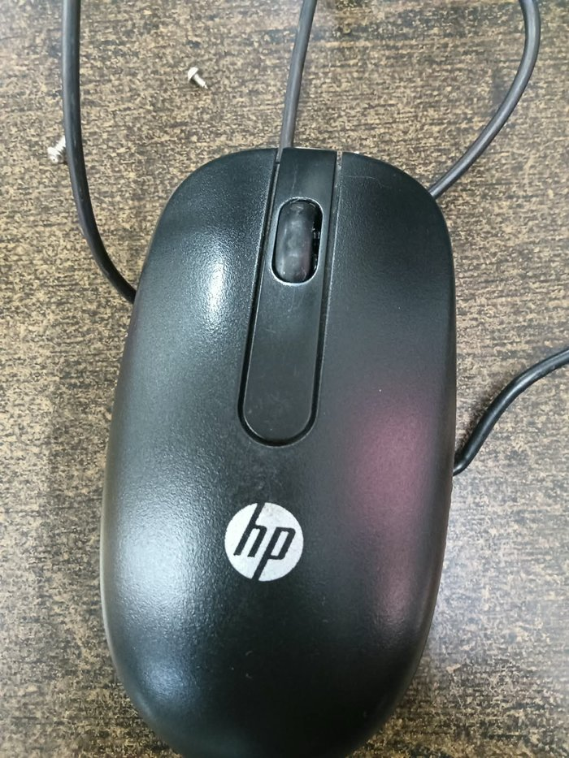  Fig. 1 Top view of the mouse | Subsystems Used  (1) Optical tracking (LED, lens, image sensor) (2) Click switches (3) Scroll-wheel encoder (4) Sensor/controller IC with USB interface (5) USB cable and connector (6) Mechanical shell, wheel and screws.  Description of Subsystems  The LED lights the surface and the lens focuses the reflection on an image sensor that detects motion. Switches register clicks, the encoder reports wheel rotation, and the controller sends everything to the PC as USB HID reports through the cable.  Modes of Operation  Active (tracking and clicking), idle (sensor frame rate reduced) and USB suspend (LED off when the PC sleeps).

2. Purpose of the Product
A human–computer input device that converts hand movement and finger actions into digital signals to control the pointer, select, drag and scroll on a computer screen.

3. User Needs Addressed
Accurate pointer control without a mouse pad; plug-and-play with no driver or battery; comfortable for left and right hands; low cost and low maintenance; no wireless lag; quick scrolling.

PART II – PRODUCT ORIGIN TO LATEST INVENTIONS

1. Difference in Technology Across Versions
Stage | Technology | Key improvement | Drawback
1.1 Early stage (1964) | Wooden shell, two perpendicular wheels (Engelbart) | First pointing device for GUIs | Bulky, one button, wheels slipped
1.2 First generation (1970s–90s) | Ball mouse, roller encoders, PS/2 / serial | Smooth 2-D motion, mass produced | Dirt collects, needs cleaning and a pad
1.3 Second generation (late 1990s) | Optical LED + image sensor, USB (MOFYUO class) | No moving parts, works on most surfaces, 400–1600 DPI | Fails on glass / glossy surfaces
1.4 Third generation (2000s) | Laser sensor, 2.4 GHz RF / Bluetooth | Higher DPI, cable-free | Batteries, cost, possible interference
1.5 Latest generation | High-DPI sensors, Bluetooth LE, rechargeable, programmable buttons | Precision, multi-device use | Higher cost, software dependence

2. Current Status – Core Smart Technologies Used
CMOS image sensor with on-chip DSP for motion detection; USB HID protocol (plug-and-play); embedded controller firmware (debounce, reporting, power saving); single-chip mixed-signal PCB.

3. Engineering Importance of This Evolution
Solid-state sensing replaced wear-prone mechanical parts, improving reliability and life. Single-chip integration cut cost and size. USB HID gave universal compatibility, and image-based sensing is an everyday example of embedded vision.

PART III – INTERNAL COMPONENTS & WORKING FLOW

1. Introduction of the Product
The HP MOFYUO is a USB wired optical mouse with an 800 DPI sensor, two click buttons and a scroll wheel. It draws 5 V from the USB port and sends movement, click and scroll data to the PC.

2. Photograph of the Internal Components of the Product
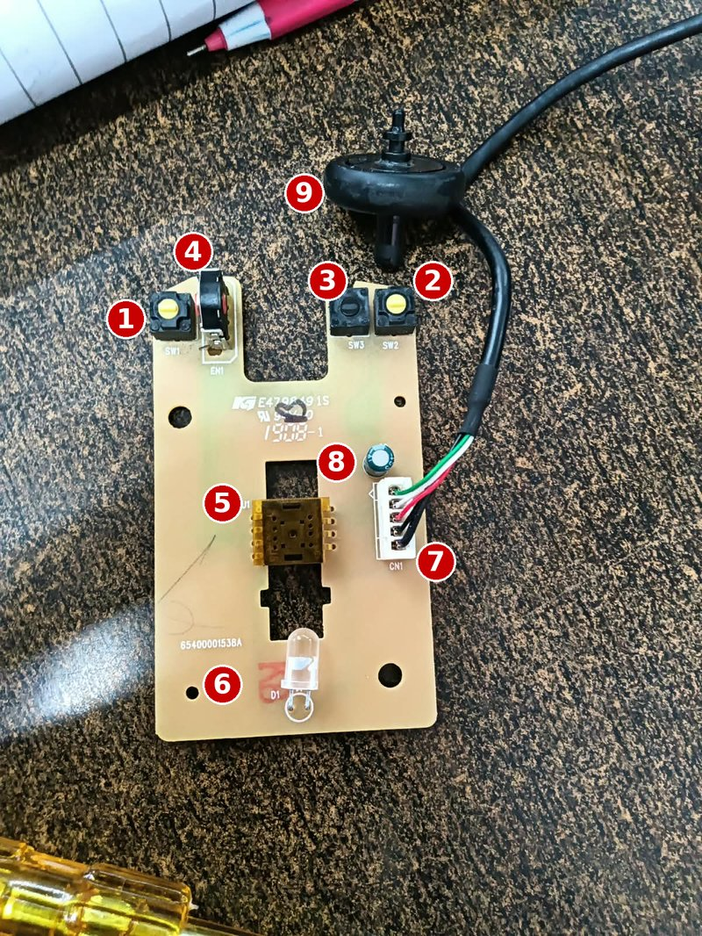  Fig. 2 Main PCB (labelled photo) | Labelled components on the PCB  1 SW1 – left-click micro-switch  2 SW2 – right-click micro-switch  3 SW3 – third micro-switch (wheel button)  4 EN1 – scroll-wheel encoder  5 U1 – optical sensor IC (8-pin, controller inside)  6 D1 – 5 mm LED for surface illumination  7 CN1 – 5-pin connector with USB wires (green, white, red, black)  8 Electrolytic capacitor (supply filtering)  9 Cable strain-relief grommet

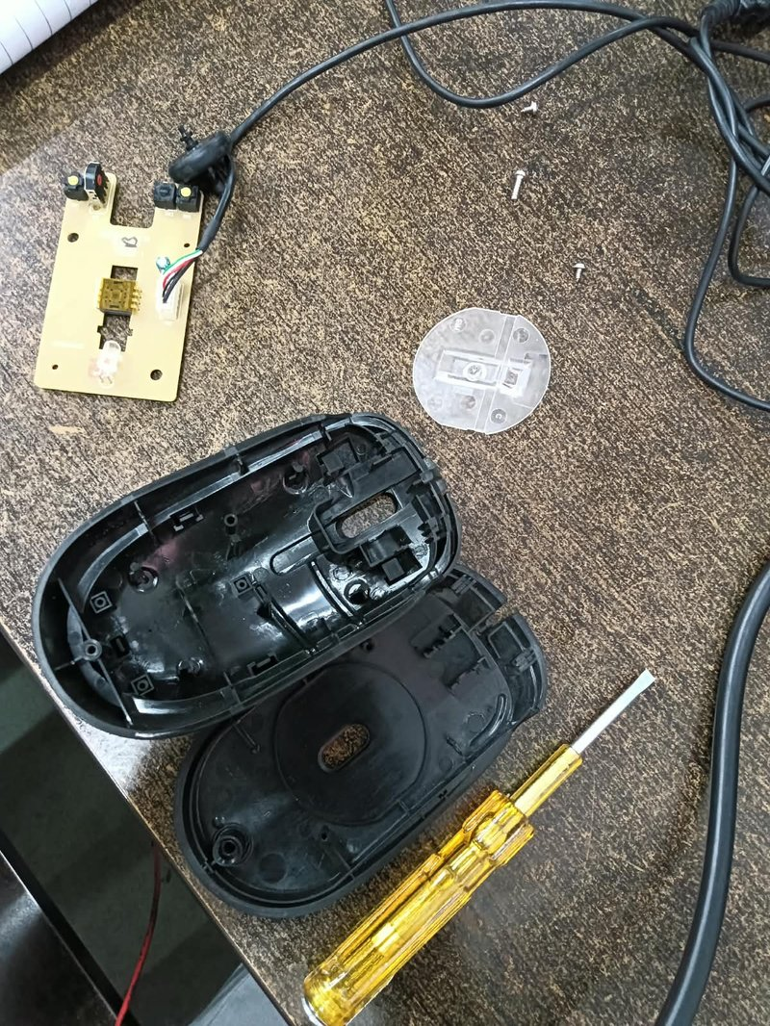  Fig. 3 Dismantled parts | 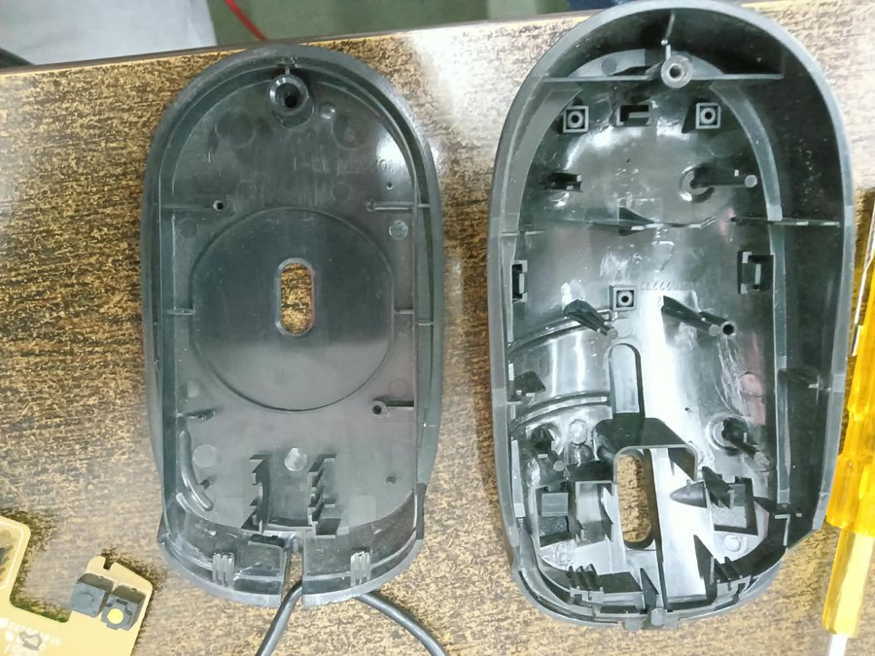  Fig. 4 Bottom shell (left) and top shell (right), inside view | 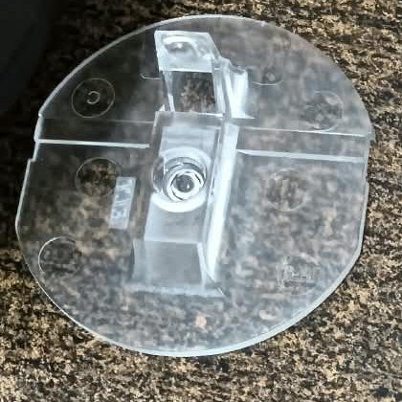  Fig. 5 Clear lens / light guide

Dismantling Sequence (component-wise)
Step | Component removed | How it is removed / what is observed | Photo
1 | Screws | Three small screws removed with a flat-blade screwdriver to release the two shells | 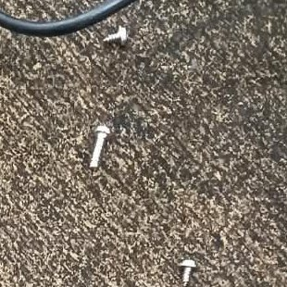
2 | Top and bottom shell | Shells separated at the snap-fit seam; scroll-wheel slot and button plungers visible in the top shell; cable exits through the bottom shell
3 | Lens / light guide | Clear plastic piece lifted from the base; it sits over the sensor window and guides LED light to the surface
4 | Main PCB | Single board lifted out; carries all electronic parts. No screws – it is held by shell pins through its mounting holes | 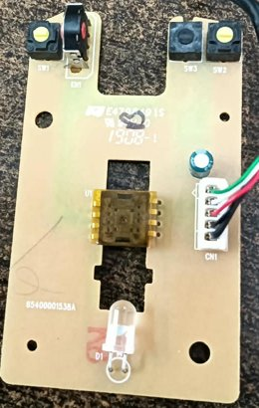
5 | Optical sensor U1 and LED D1 | Sensor IC and LED sit on either side of the board cut-out above the lens | 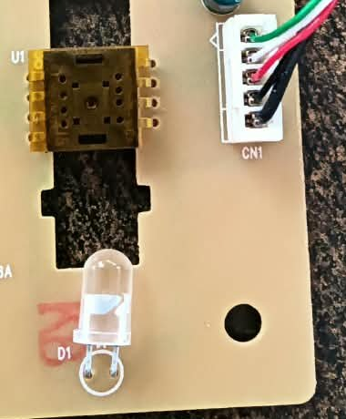
6 | Switches SW1–SW3 and encoder EN1 | Micro-switches sit under the button plungers; encoder EN1 reads the wheel axle | 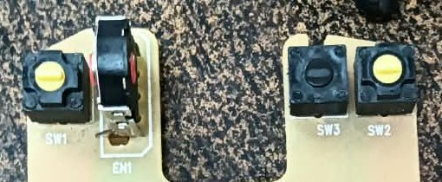
7 | USB wires and connector CN1 | Four wires (green, white, red, black) plug into the 5-pin connector; capacitor sits beside it | 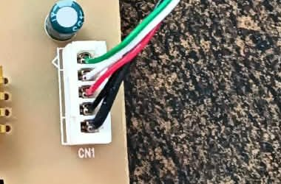
8 | Cable strain relief | Rubber grommet clamps the cable where it enters the shell | 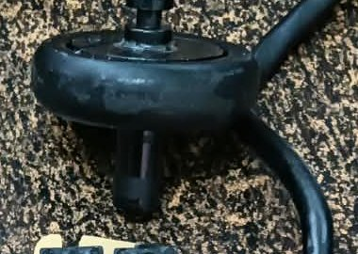

3. Internal Block Diagram (Functional View)
Desk surface (reflects light) | ⇄ | Red LED + Lens (illumination & imaging) | → | CMOS Image Sensor + DSP (motion tracking) | → | Controller (USB)

Left/Right/Wheel switches | → | Controller (USB HID firmware) | → | USB cable (VCC, D+, D−, GND) | → | PC / Laptop

4. Internal Subsystems with Detailed Explanation
Subsystem | 4.1 Function | 4.2 Working principle | 4.3 Characteristics | 4.4 Role here
Optical sensor (D1 + lens + U1) | Detects movement | LED lights surface; sensor compares successive images to get ΔX, ΔY | 800 DPI, thousands of frames/s | Gives pointer motion
Micro-switches SW1–SW3 | Detect clicks | Metal leaf closes contact when pressed | Typical life millions of clicks | Left, right, wheel click
Scroll encoder EN1 | Report scrolling | Quadrature A/B pulses give direction | Notched steps, 2 channels | Scrolling
Controller / USB (inside U1) | Communicate with PC | Firmware builds USB HID reports | Low-speed USB, ~125 Hz poll | Plug-and-play link
USB cable and CN1 | Power and data | VBUS, D+, D−, GND lines | 4 wires, Type-A | Supplies 5 V, carries data

5. Complete Working Flow (Step-by-Step)
1) Mouse plugged in, PC supplies 5 V and detects it as a HID device. 2) LED lights the surface. 3) Lens focuses the image on the sensor. 4) Sensor compares frames and calculates ΔX, ΔY. 5) Controller reads motion, switches and wheel pulses. 6) It packs them into a USB HID report. 7) PC polls and receives the report. 8) OS moves the pointer, clicks or scrolls. 9) At idle the sensor slows down; on PC suspend the LED turns off.

6. Components List – Bill of Material
Sr. | Component | Qty | Remarks
1 | Top shell (with buttons) | 1 | ABS plastic, HP logo
2 | Bottom shell / base | 1 | ABS plastic, sensor window
3 | Main PCB 65400001538A | 1 | FR-4, single board
4 | U1 – optical sensor IC | 1 | 8-pin, gold-coloured; marking not legible (optical navigation sensor type)
5 | D1 – LED | 1 | 5 mm clear lens, through-hole
6 | Lens / light guide | 1 | Transparent plastic
7 | SW1, SW2, SW3 – micro-switches | 3 | Left, right, wheel click
8 | EN1 – scroll encoder | 1 | Reads wheel rotation
9 | Scroll wheel | 1 | In top shell
10 | Electrolytic capacitor | 1 | Supply filtering; approx. 10 µF / 16 V
11 | CN1 – 5-pin connector | 1 | Wire-to-board connector
12 | USB cable with Type-A plug and strain relief | 1 | 4 wires
13 | Screws | 3 | Hold shells together

7. Component Ratings & Specifications
Component | Rating / Specification | Source
Mouse (overall) | 800 DPI, USB Type-A, 2 buttons + scroll | Reseller listing
Supply | 5 V DC from USB, tens of mA typical | USB standard
D1 LED | 5 mm, ~1.8–2.2 V, 10–20 mA typical | Typical – verify
SW1–SW3 switch | SPST tactile, about 50 mA / 12 V DC, millions of clicks | Typical – verify
U1 sensor IC | 8-pin optical navigation sensor, 800 DPI, 5 V supply (approx.) | Approx. value
Capacitor | Electrolytic, approx. 10 µF, 16 V | Approx. value
PCB | 65400001538A, date code 1908-1 | Printed on PCB

8. Component Function Table
Component Name | Function | Specifications
U1 optical sensor | Captures surface images, calculates movement, handles USB | 800 DPI, 8-pin
D1 LED | Illuminates the surface | 5 mm, via lens
Lens / light guide | Focuses light and image on sensor | Plastic, fixed focus
SW1–SW3 micro-switch | Detect left, right and wheel presses | SPST momentary
EN1 encoder | Detects wheel rotation and direction | Quadrature, 2 ch.
Electrolytic capacitor | Filters supply noise | ~10 µF, 16 V
CN1 connector | Joins USB wires to PCB | 5-pin
USB cable | Power and data connection | 4 wires, Type-A
Shells, wheel, screws | Housing and ergonomic interface | ABS plastic

PART IV – SIMULATION (TINKERCAD)
The click behaviour of the mouse (button press detected by a microcontroller, with LED feedback) was simulated in Tinkercad Circuits using an Arduino UNO. Click the image or the link below to open the live simulation.
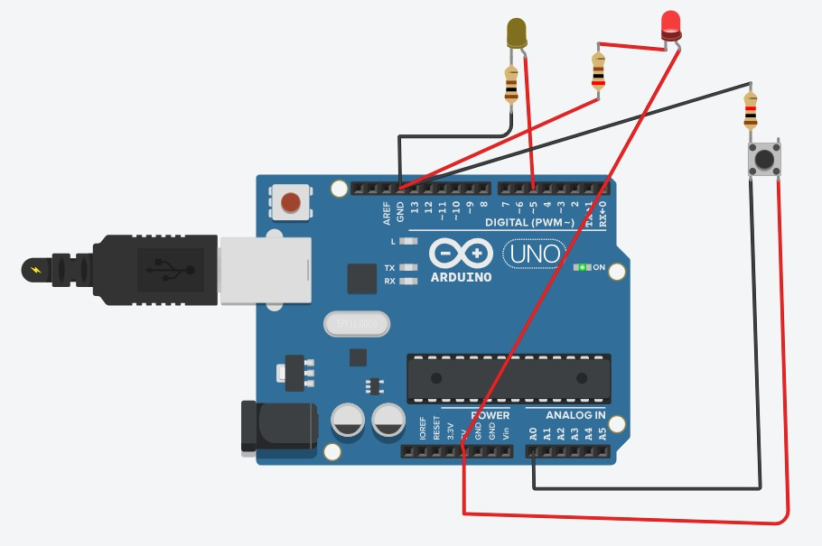
Fig. 6 Tinkercad simulation circuit – Mouse Click Button
Simulation link: https://www.tinkercad.com/things/hyK0gp8J94M-mouse-click-button
Item | Details
Simulation link | https://www.tinkercad.com/things/hyK0gp8J94M-mouse-click-button
Platform | Tinkercad Circuits (Arduino UNO)
Components | Arduino UNO, push button (acts as a mouse click switch), 2 LEDs, 3 resistors, jumper wires
Working | Pressing the button changes the input read by the Arduino, which switches the LED indicator – the same idea as SW1/SW2 sending a click to the controller in the real mouse.

